1. Introduction
RDX proxy is a completely managed database proxy for Amazon RDS. Amazon RDS Proxy creates a pool of DB connections & shares them with the applications' different requests.
Amazon RDS Proxy makes applications more resilient & scalable to database failures by automatically connecting to a standby DB instance while preserving the application connections.
Using Amazon RDS Proxy, you can handle unpredictable surges in the database traffic that creates new connections at a fast rate.
The proxy is an intermediary layer that sits between a database and an application. The application establishes a connection to the proxy, which then routes connections to the database.
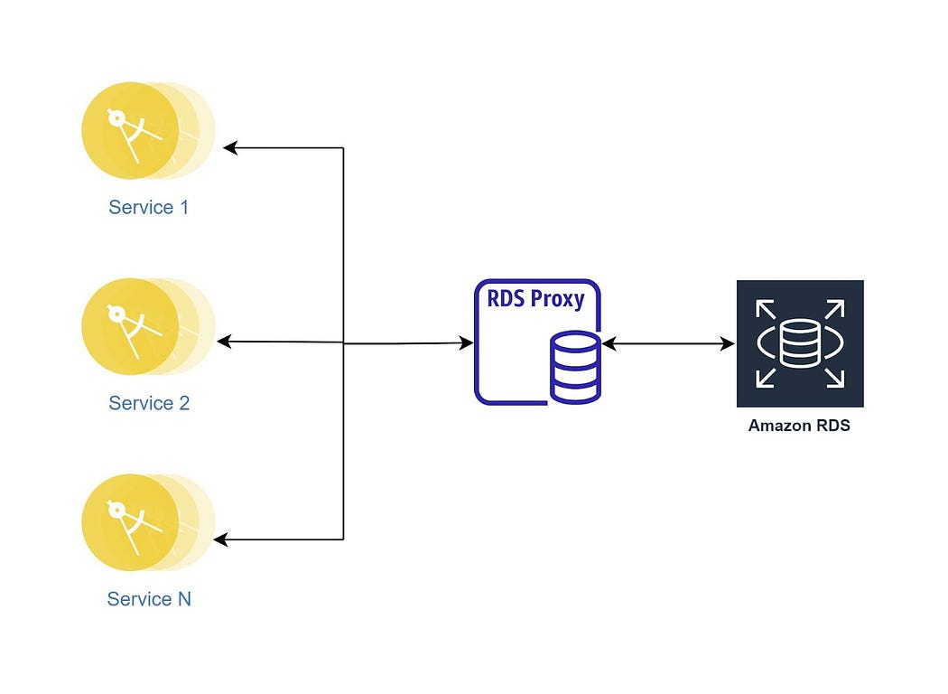
Amazon RDS Proxy
This is a great advantage for applications that often open and close connections to the database, having many open connections to the database. Those applications now need to maintain fewer connections to the database with Amazon RDS Proxy.
Amazon RDS Proxy creates a pool of database connections and reuses connections from this pool to avoid the memory and CPU overheads of creating a new database connection each time.
Connections that cannot be served instantly from the pool of connections are throttled or queued by the Amazon RDS Proxy. Amazon RDS Proxy denies connection requests that exceed the thresholds you specify (that is, it sheds load). In addition, it maintains a predictable performance for the load that the available capacity can handle. Your application can scale without suddenly failing or overloading the database, even though latencies could rise.

2. Challenges without Amazon RDS Proxy
Amazon RDS comes with a specific set of DB connections. The maximum number of parallel database connections varies by the DB engine type and the memory allocation for the DB instance. Amazon RDS face below mentioned challenges while dealing with the DB connections:
- Managing several connections with the application has a performance cost for the database.
- RDS has limited database connections. You might get the "Too Many Connections" error.
- Frequent opening and closing of database connections.

3. Benefits of using Amazon RDS Proxy
Amazon RDS Proxy takes care of DB connection management. Below are the benefits of using Amazon RDS Proxy:
- It is a completely managed and highly available database proxy for RDS, which increases the scalability, resilience to database failures, and security of applications.
- Amazon RDS Proxy reduces the application disruption caused by outages that affect the availability of your database by automatically establishing connections to a replacement database instance while maintaining the existing connections. Amazon RDS Proxy directs queries to the replacement database instance during failovers. As a result, failover times for Aurora and RDS databases can be cut down by as much as 66%.
- It enhances database efficiency and application scalability by allowing applications to pool and share connections made with the database.
- It is fully compatible with MySQL and PostgreSQL.
- Furthermore, it allows users to keep a predictable database performance by controlling the total number of open database connections.
- It is fully Serverless and automatically adjusts to the workload.
- It allows you to apply AWS IAM authentication for the databases and securely store credentials in AWS Secrets Manager.
- Users can use an Amazon RDS Proxy to keep their application's connections idle while establishing database connections as needed to serve them best.
- It applies the Transport Layer Security usage between the Amazon RDS Proxy and the database.
- You can assign several proxies to the same database instance or cluster.
- Code is no longer required to clean inactive connections and manage the connection pools.

4. Limitations of Amazon RDS Proxy
Amazon RDS Proxy overcomes DB connection management drawbacks, but it has some limitations.
- Amazon RDS Proxy cannot be publicly available even though the database instance is publicly available.
- Amazon RDS Proxy only works with an RDS cluster/instance, not a self-managed database based on an EC2 instance.
- Amazon RDS Proxy supports Aurora Serverless V2 and does not support Aurora Serverless V1.
- Amazon RDS Proxy can only be associated with a single database instance.
- All connections using the default proxy endpoint in an Aurora cluster are managed through the Aurora writer instance. You can create a read-only endpoint for a proxy to perform load balancing for read-intensive workloads.
- Amazon RDS Proxy does not support Aurora global database currently.
- You can't use Amazon RDS Proxy with a VPC that has dedicated tenancy.
- You can't use Amazon RDS Proxy with the cluster's custom DNS.

5. Create and configure Amazon RDS Proxy
In this section, we will go through the Amazon RDS Proxy creation and configuration steps.

Prerequisites
Below are the prerequisites for Amazon RDS Proxy.
- Create Aurora RDS Cluster.
- Create two or more private subnets for Amazon RDS Proxy.
- Create a security group for Amazon RDS Proxy.
- Create DB Secret in a Secrets Manager.

Steps to create Amazon RDS Proxy
- Login into the AWS account, go on to the RDS console, and click on Proxies
- Click on "Create proxy"
2.1 Select the database engine family as per the Aurora Cluster engine family.
2.2 Enter a name for the proxy.
2.3 Enter a value under the "Idle client connection timeout" (The idle connection from your application will be closed after the specified time) as per your requirement.
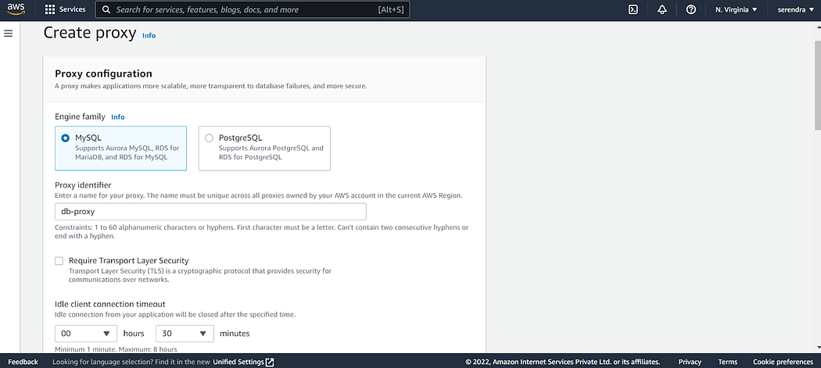
3. Enter "Target group configuration"
3.1 Select the existing Aurora Cluster from the drop-down.
3.2 Enter a value in the "Connection pool maximum connections" section (Specify the maximum allowed connections as a percentage of the maximum connection limit of your database).
3.3 Select "Add reader endpoint" if you have a read-replica created in your Aurora Cluster.
3.4 Keep "Session pinning filters" none for now.
3.5 Enter "Connection borrow timeout" (Timeout for borrowing DB connection from the pool)
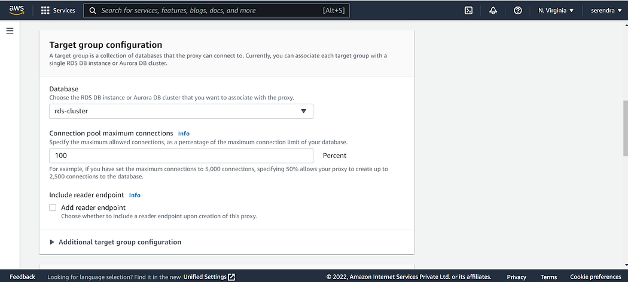
4. Enter "Additional target group configuration"
4.1 Keep "Session pinning filters" none for now.
4.2 Enter "Connection borrow timeout" (Timeout for borrowing DB connection from the pool)
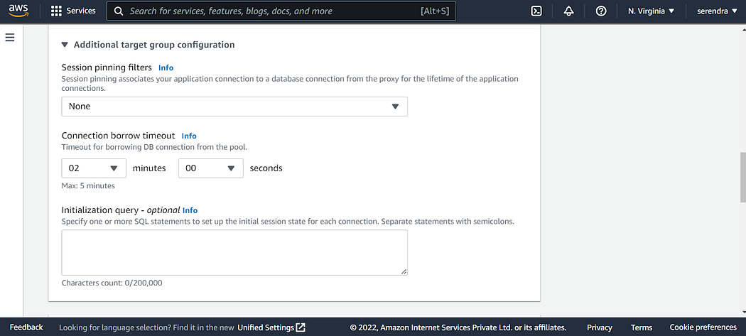
5. Configure connectivity settings
5.1 Select Aurora Cluster secrets from the Secrets Manager created in the prerequisites step.
5.2 Select the IAM role if IAM Authentication is enabled.
5.3 Select "Required" in "IAM authentication" if you want to use IAM Role rather than DB credentials to connect to the database.
5.4 Select subnets created in the prerequisites section.
5.5 Select the security group created in the prerequisites section.
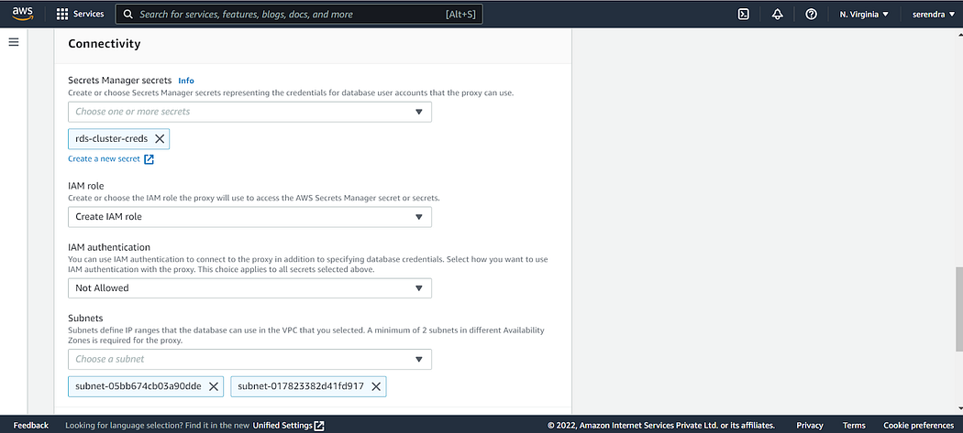
6. Select additional connectivity options
6.1 Select the security group created in the prerequisites section.
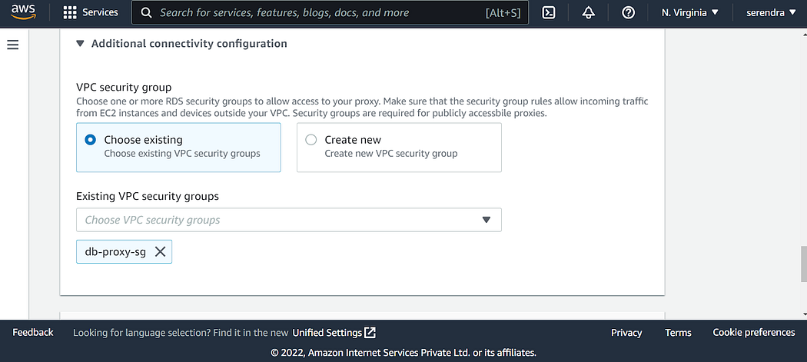
7. Configure "Advanced configuration" options
7.1 Select "Activate enhanced logging" if you want to see queries processed by the proxy in CloudWatch logs.
7.2 Click on the "Create proxy" button.
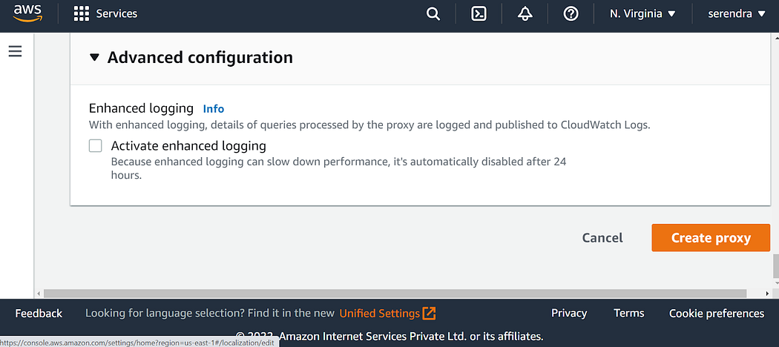
7.3 You will see the proxy is in the "creating" state.
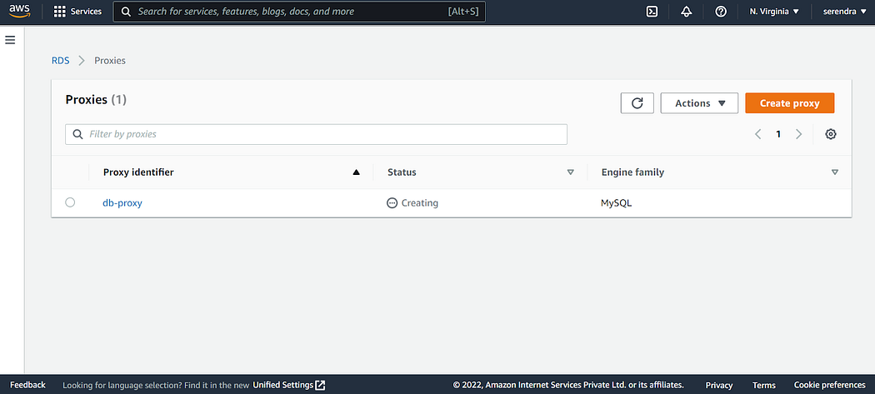
7.4 After a few minutes, the proxy will be in an "available" state.
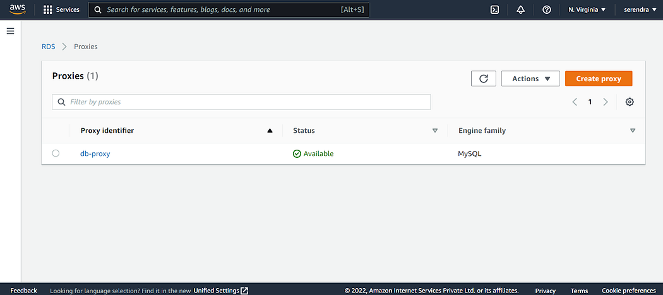
You can verify whether the Amazon RDS Proxy is working by connecting to the database using a proxy endpoint. You can get a proxy endpoint at the proxy details page.
